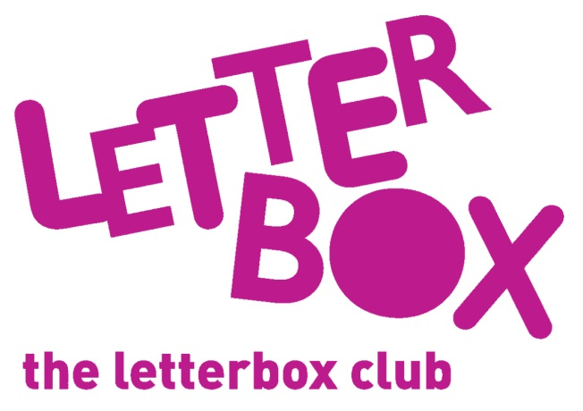
LA/School Address
[Street Address]
[Town/City]
[County]
[Postcode]

Dear [carer/parent and child],

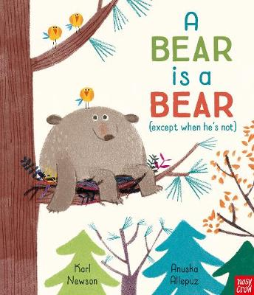
In this parcel you will find a book called A Bear is a Bear. He is a bear but what if he wasn’t? We hope you enjoy the pictures and the rhymes!

You are also getting a pack of six mini dinosaurs to hide and find!

Plus, you’ll find a finger puppet – we hope you like it!

From,
[Local Authority/School]

