LA/School Address
[Street Address]
[Town/City]
[County]
[Postcode]

Dear [carer/parent and child],

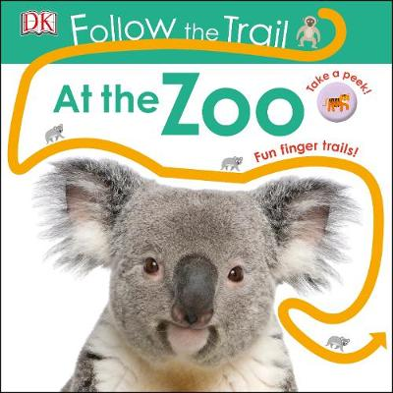
This month you are getting Follow the Trail – At the Zoo. Use your fingers to follow the glittery, bumpy, shiny trails and enjoy looking at the different zoo animals!

You are also getting a book called Commotion in the Ocean.

Plus, you get another finger puppet this month!

From,
[Local Authority/School contact]

