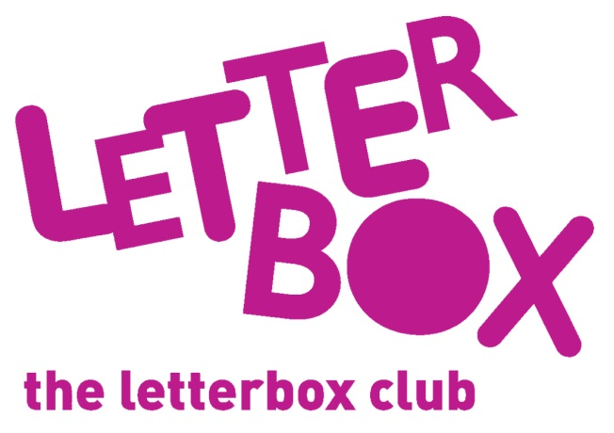
LA/School Address
[Street Address]
[Town/City]
[County]
[Postcode]

Dear [carer/parent and child],
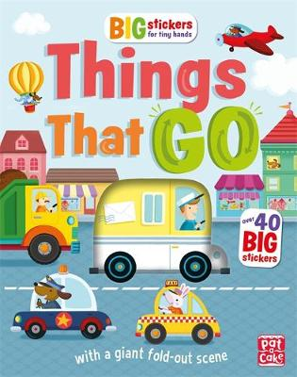
In your parcel this month, you have a book called Things That GO – it’s full of big stickers! We hope you have fun decorating the different scenes.

You also have Pip and Posy: The New Friend.
Plus, there are 20 paper elephants for you to decorate.
From,
[Local Authority/School contact]

P.S. Look out for your finger puppet this month!

