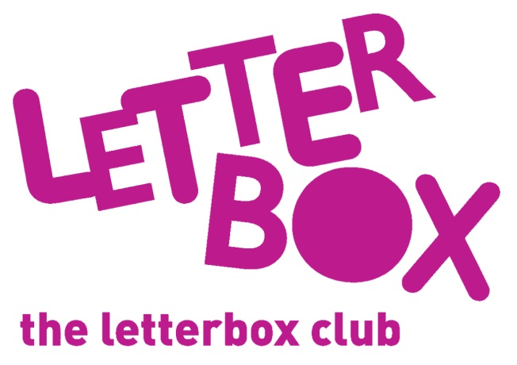
LA/School Address
[Street Address]
[Town/City]
[County]
[Postcode]

Dear [carer/parent and child],
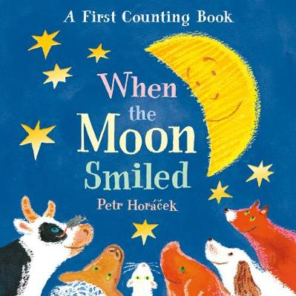
This month you are getting three books! They are When the Moon Smiled, Fox’s Socks and Car, Car, Truck, Jeep. We hope you enjoy them.

You are also getting some bean bags so that you can have fun practising counting.

Plus, you have a finger puppet and some stickers!

From,
[Local Authority/School contact]

