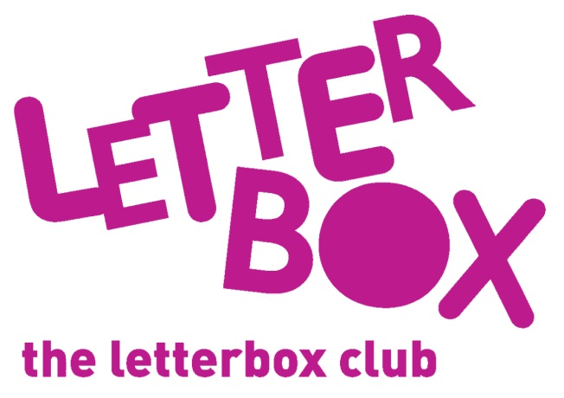
LA/School Address
[Street Address]
[Town/City]
[County]
[Postcode]

Dear [carer/parent and child],
Welcome to the Letterbox Club! We are so happy to have you in the club.

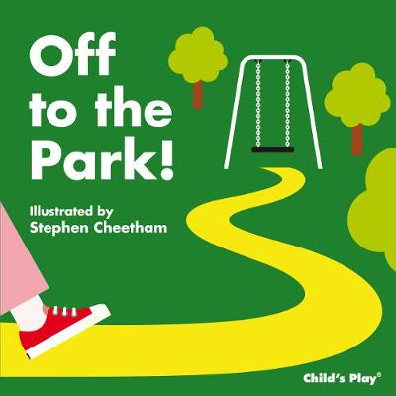
Every month, for the next 6 months, you will receive a parcel full of fun books, games and stationery.

This month you are getting Off to the Park!
You will also find a finger puppet postcard and a finger puppet in this parcel!

From,
[Local Authority/School contact]

