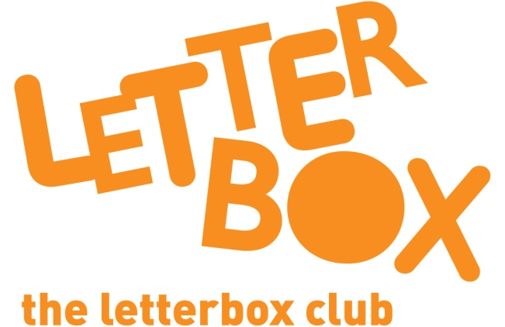
LA/School Address
[Street Address]
[Town/City]
[County]
[Postcode]

Dear [carer/parent and child],

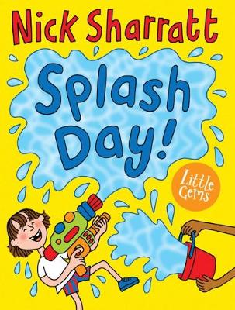
This month prepare to be soaked in Splash Day! Nick Sharratt has drawn some very funny pictures in the book.

Plus, have you ever wondered what it’s like in space? Find out and enjoy the stickers, in First Sticker Book Space.

This parcel also has a book called The Awesome Night Sky where you can find out even more about stars and satellites.

Plus, we’ve sent you everything you need to open your very own shop and your own calculator to add up with!
We are so glad that you have been part of the Letterbox Club and we hope you have had fun.

From,
[Local Authority/School contact]

