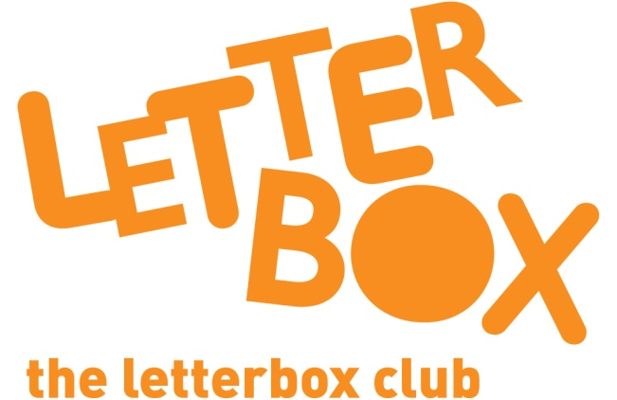
LA/School Address
[Street Address]
[Town/City]
[County]
[Postcode]

Dear [carer/parent and child],
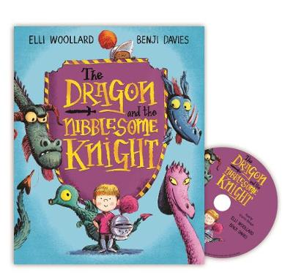
This month, meet The Dragon and the Nibblesome Knight – this book also comes with a CD, so you can listen to the story as well.

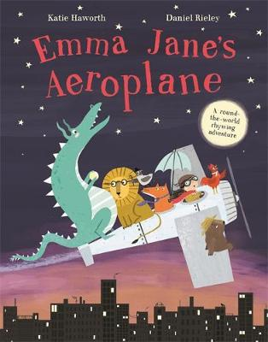
You’ve also got Emma Jane’s Aeroplane which is full of rhymes and tells the story of a girl who makes lots of animal friends as she flies across the world.

We hope you like playing the Squishy Races game too!
From,
[Local Authority/School contact]

