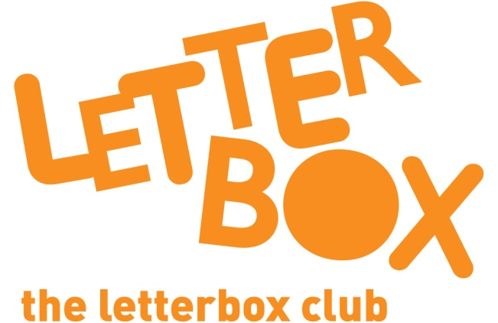
LA/School Address
[Street Address]
[Town/City]
[County]
[Postcode]

Dear [carer/parent and child],

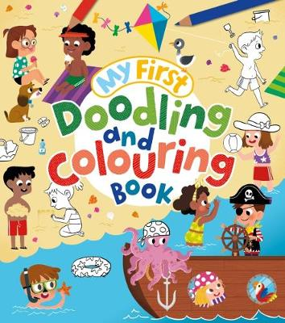
In this parcel, you’ve got My First Doodling and Colouring Book. You have some felt-tip pens to use in the book too.

You also have a funny book called How to Nab a Rabbit. We hope you like it!

Plus, you’ve got some stickers to write your name on and stick in your new books.

From,
[Local Authority/School contact]

