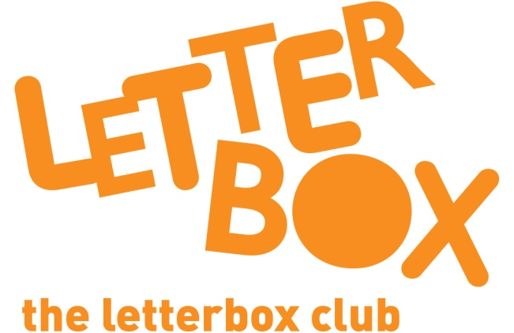
LA/School Address
[Street Address]
[Town/City]
[County]
[Postcode]

Dear [carer/parent and child],
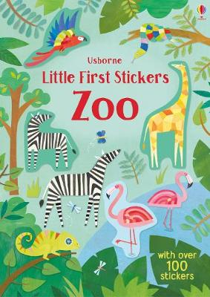
In this month’s parcel, you have a colourful sticker book with lots of stickers of zoo animals.

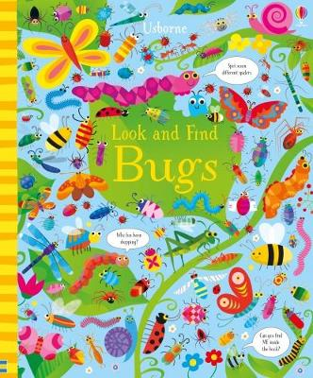
There are more creatures in Look and Find Bugs. Enjoy reading about the different creepy-crawlies!

It’s a full parcel this month – you also have a book called The Treasure of Pirate Frank.

Plus, you have a dominoes game and some colouring pencils.

From,
[Local Authority/School contact]

