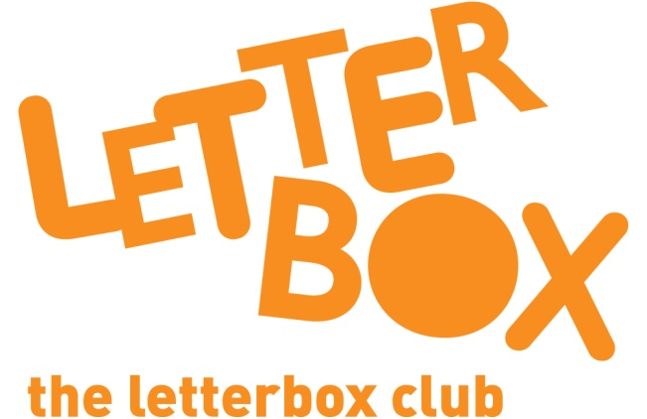
LA/School Address
[Street Address]
[Town/City]
[County]
[Postcode]

Dear [carer/parent and child],

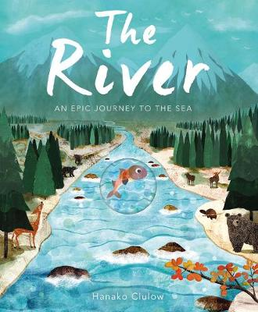
This month, we’ve sent you The River, about a fish on a journey – enjoy the pictures and the rhymes, as you follow the story.

Look out for the pairs game in this parcel too.

You also have an activity where you can try creating your own animal!

We hope you enjoy your Letterbox Club parcel.

From,
[Local Authority/School contact]

