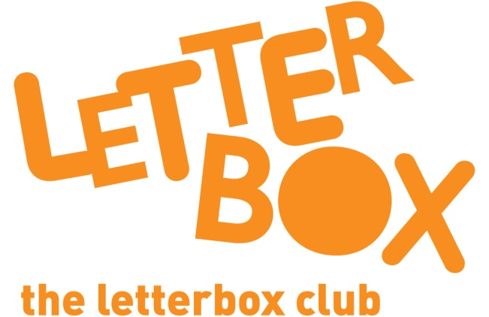
LA/School Address
[Street Address]
[Town/City]
[County]
[Postcode]

Dear [carer/parent and child],
Welcome to the Letterbox Club! We are so happy to have you in the club.

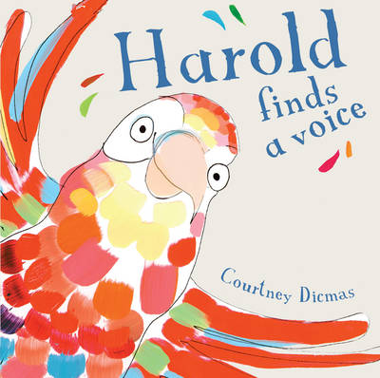
Every month for the next 6 months, you’ll receive a parcel full of fun books, games and stationery items, like pens, pencils and notebooks! Everything in the parcels is for you to own and keep.

In this parcel you have Harold Finds a Voice – a colourful story about an amazing parrot, who can copy different voices and sounds.

Plus, you’ll find a magnetic fishing game and some name stickers to put in your Letterbox Club books.

From,
[Local Authority/School contact]

