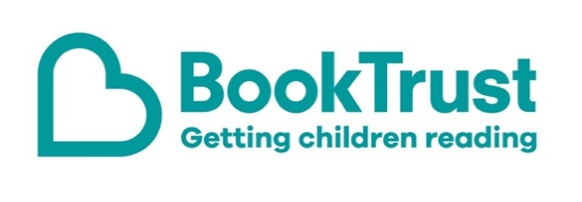

The Letterbox Club: A note to the grown-ups

Letterbox Club is a programme run by BookTrust - the UK largest children’s reading charity.

Virtual Schools and schools purchase the Letterbox Club parcels for children they feel would benefit the most and can either post or give the parcels directly to the children.

The Letterbox Club provides six parcels of books, games and stationery, for them to enjoy and keep. When each parcel arrives, you can also get involved, by reading and playing the games together.

For more information on Letterbox Club, visit: www.booktrust.org.uk/letterbox-club-families

Here's some tips to enjoy this parcel:

- The Unlucky Eleven is a short chapter book which is perfect for children who are starting to read independently. You could encourage children to use the pen and post-it notes in the parcel to write down unfamiliar words and help them look up the meaning in the dictionary. Plus, there’s a letter from the author included in the parcel.
- Life on Earth: Planet Earth is more advanced lift-the-flap book for young readers, containing facts about the natural world. Together, you could create a fact file or poster about a topic in the book.
- Keep updated on social media. You can follow @Booktrust on Twitter to find out more about the best new books, and how you can continue to encourage reading at home.
- We have included a special card which has login details to the Letterbox Club members’ website containing author content, activities and videos. Children don’t need to log in – just help them type in the link on their membership card.

We hope you all enjoy this parcel,
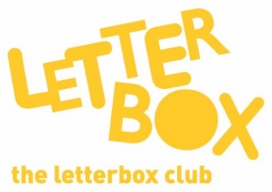
The Letterbox Club Team at BookTrust

