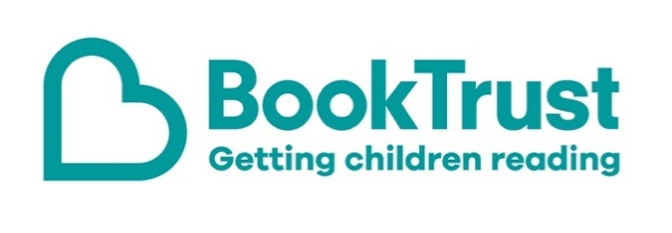

The Letterbox Club: A note to the grown-ups

Letterbox Club is a programme run by BookTrust - the UK largest children’s reading charity.

Virtual Schools and schools purchase the Letterbox Club parcels for children they feel would benefit the most and can either post or give the parcels directly to the children.

The Letterbox Club provides six parcels of books, games and stationery, for them to enjoy and keep. When each parcel arrives, you can also get involved, by reading and playing the games together.

For more information on Letterbox Club, visit: www.booktrust.org.uk/letterbox-club-families

Here's some tips to enjoy this parcel:

- The Bear, the Piano, the Dog and the Fiddle is a story about friendship. If you’re reading this with a child who is a less confident reader, you could encourage them to look at the pictures to help them understand the story. Plus, there’s a letter from the author included in this parcel.
- Joke-o-rama is a fun book to share together when you’ve only got a few minutes. Tell each other your favourite jokes and use the Crack a Joke activity in the parcel to help children make up their own.

We hope you all enjoy this parcel,
The Letterbox Club Team at BookTrust
