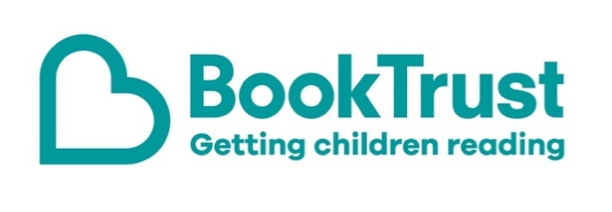

The Letterbox Club: A note to the grown-ups

Letterbox Club is a programme run by BookTrust - the UK largest children’s reading charity.

Virtual Schools and schools purchase the Letterbox Club parcels for children they feel would benefit the most and can either post or give the parcels directly to the children.

The Letterbox Club provides six parcels of books, games and stationery, for them to enjoy and keep. When each parcel arrives, you can also get involved, by reading and playing the games together.

For more information on Letterbox Club, visit: www.booktrust.org.uk/letterbox-club-families

Here's some tips to enjoy this parcel:

- Beetles, Butterflies and other British Minibeasts is packed with facts about minibeasts and their homes, as well as stickers for children to add to the pages. Together, you can use the checklist at the end of the book to spot the different creepy-crawlies. You could encourage your child to keep an eye out for them when you’re out and about in the summer.
- We hope you both enjoy reading Mortimer Keene: Attack of the Slime. If you’re reading it to children, try to use your tone of voice to show them the rhythm of the story. You can find similar books by visiting the BookTrust website at www.booktrust.org.uk/books

We hope you all enjoy this parcel,
The Letterbox Club Team at BookTrust
Did you know? Children who read for pleasure make significantly more progress in vocabulary, spelling and maths than children who read very little (Sullivan and Brown, 2013)

