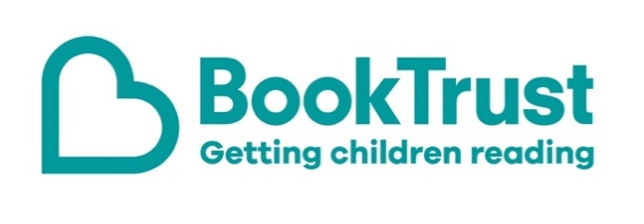

The Letterbox Club: A note to the grown-ups

Letterbox Club is a programme run by BookTrust - the UK largest children’s reading charity.

Virtual Schools and schools purchase the Letterbox Club parcels for children they feel would benefit the most and can either post or give the parcels directly to the children.

The Letterbox Club provides six parcels of books, games and stationery, for them to enjoy and keep. When each parcel arrives, you can also get involved, by reading and playing the games together.

For more information on Letterbox Club, visit: www.booktrust.org.uk/letterbox-club-families

Here's some tips to enjoy this parcel:

- Look Inside: Science is an engaging introduction to a broad range of science topics, from how plants grow to light and sound. If children are interested in a topic, you could visit the library to find more books about it.
- Lots of Things to Find and Colour is perfect for the school holidays as well as rainy weekends. It features a range of activities including counting and colouring, which children can use the felt tip pens in this parcel to complete. You could join in and see who can spot the different things on each page first.

We hope you all enjoy this parcel,
The Letterbox Club Team at BookTrust
