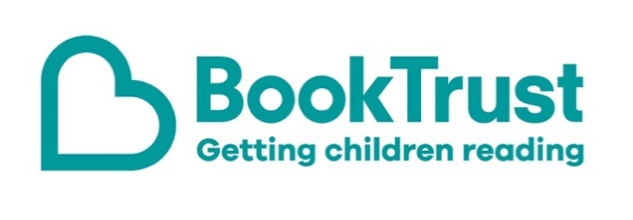

The Letterbox Club: A note to the grown-ups

Letterbox Club is a programme run by BookTrust - the UK largest children’s reading charity.

Virtual Schools and schools purchase the Letterbox Club parcels for children they feel would benefit the most and can either post or give the parcels directly to the children.

The Letterbox Club provides six parcels of books, games and stationery, for them to enjoy and keep. When each parcel arrives, you can also get involved, by reading and playing the games together.

For more information on Letterbox Club, visit: www.booktrust.org.uk/letterbox-club-families

Here's some tips to enjoy this parcel:

- Secret Agent Elephant is a great book for sharing. You could help children create their own ‘spy profile’ like the one on the back cover of the book.
- There is also an author letter included in the parcel – together you could try working out the secret message in the code.
- Wow! Animals is a great book for dipping into when you’re out and about. Together you could talk about your favourite animal or your favourite fact from the book.

We hope you all enjoy this parcel,
The Letterbox Club Team at BookTrust
