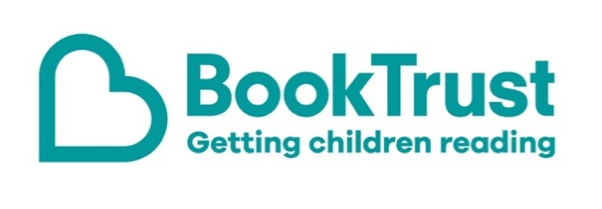

The Letterbox Club: A note to the grown-ups

Letterbox Club is a programme run by BookTrust - the UK largest children’s reading charity.

Virtual Schools and schools purchase the Letterbox Club parcels for children they feel would benefit the most and can either post or give the parcels directly to the children.

The Letterbox Club provides six parcels of books, games and stationery, for them to enjoy and keep. When each parcel arrives, you can also get involved, by reading and playing the games together.

For more information on Letterbox Club, visit: www.booktrust.org.uk/letterbox-club-families

Here's some tips to enjoy this parcel:

- If children enjoy Lift-the-Flap: Why Does the Sun Shine? you could talk about some of the facts in the book and link them to the things they might see in real life.
- Let’s Draw has simple step-by-step instructions to help children draw different animals. There is space in the book for them to draw, and colouring pencils are included in the parcel.
- If children enjoy Narwhal: Unicorn of the Sea, you could encourage them to draw their own comic, either with their own characters or a new story including Narwhal and Jelly.

We hope you all enjoy this parcel,
The Letterbox Club Team at BookTrust
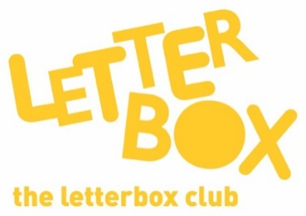
Did you know? Reading for pleasure can increase empathy, improve relationships with others, reduce the symptoms of depression and improve wellbeing throughout life (The Reading Agency, 2015).

