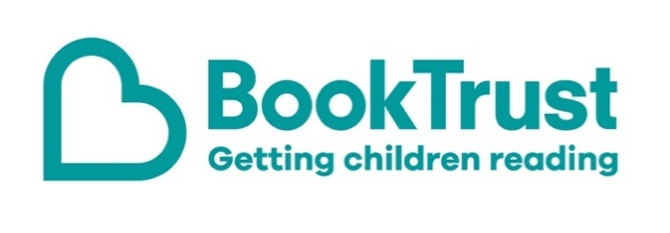

The Letterbox Club: A note to the grown-ups
Letterbox Club is a programme run by BookTrust - the UK largest children’s reading charity.
Virtual Schools and schools purchase the Letterbox Club parcels for children they feel would benefit the most and can either post or give the parcels directly to the children.
The Letterbox Club provides six parcels of books, games and stationery, for them to enjoy and keep. When each parcel arrives, you can also get involved, by reading and playing the games together.
For more information on Letterbox Club, visit: www.booktrust.org.uk/letterbox-club-families

Here's some tips to enjoy this parcel:
- If children enjoy There’s a Yeti in the Playground!, you can find more books by Pamela Butchart on the BookTrust website, along with information about new book recommendations and children’s book prizes.
- We hope children will enjoy the Top Trumps: Predators cards - you can play together or help them use the Predators activity sheet also included in this month’s parcel.
- The information in 100 Facts: Space Travel might build on what children have already covered in school. You could quiz each other on some of the facts in the book.
- We have included a special card which has login details to the Letterbox Club members’ website containing author content, activities and videos. Children don’t need to log in – just help them type in the link on their membership card.

Best wishes,
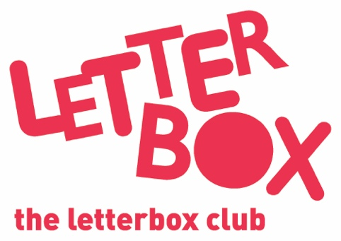
The Letterbox Club Team at BookTrust

