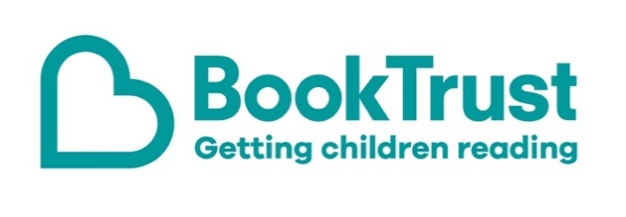

The Letterbox Club: A note to the grown-ups
Letterbox Club is a programme run by BookTrust - the UK largest children’s reading charity.
Virtual Schools and schools purchase the Letterbox Club parcels for children they feel would benefit the most and can either post or give the parcels directly to the children.
The Letterbox Club provides six parcels of books, games and stationery, for them to enjoy and keep. When each parcel arrives, you can also get involved, by reading and playing the games together.
For more information on Letterbox Club, visit: www.booktrust.org.uk/letterbox-club-families

Here's some tips to enjoy this parcel:
- Mr Penguin and the Fortress of Secrets is the second in a series of illustrated chapter books, full of adventure, mystery and humour. Encourage children to write down any unfamiliar words they come across and help them look up the meanings in the dictionary. Plus, there’s a letter from the author Alex T. Smith included in the parcel.
- Everything Sharks has facts, photos and infographics making it a great book to dip in and out of. Together, you could talk about your favourite facts, and help children find out more information if they enjoy this topic.
- Children may want to write their name on the illustrated labels in the parcel and stick them in their books – to emphasise that the books belong to them.

We hope you enjoy this parcel.
Best wishes,
The Letterbox Club Team at BookTrust

