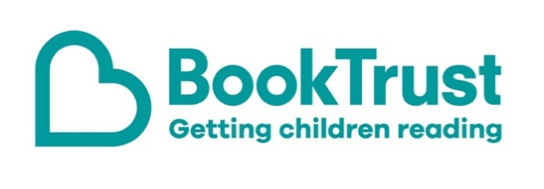

The Letterbox Club: A note to the grown-ups
Letterbox Club is a programme run by BookTrust - the UK largest children’s reading charity.
Virtual Schools and schools purchase the Letterbox Club parcels for children they feel would benefit the most and can either post or give the parcels directly to the children.
The Letterbox Club provides six parcels of books, games and stationery, for them to enjoy and keep. When each parcel arrives, you can also get involved, by reading and playing the games together.
For more information on Letterbox Club, visit: www.booktrust.org.uk/letterbox-club-families

Here's some tips to enjoy this parcel:
- The Funniest Book Ever is a collection of comics that both children and adults will laugh out loud at. If children enjoy this book, you could encourage them to try creating their own comic, either with the same characters or with their own.
- The sketch book and pencil included in the parcel can be used for the activities in How to Draw, which is a perfect step-by-step guide for budding artists.

We hope you enjoy this parcel.
Best wishes,
The Letterbox Club Team at BookTrust
Did you know? Reading increases a person’s understanding of their own identity, improves empathy and helps them understand the world views of others (The Reading Agency, 2015)

