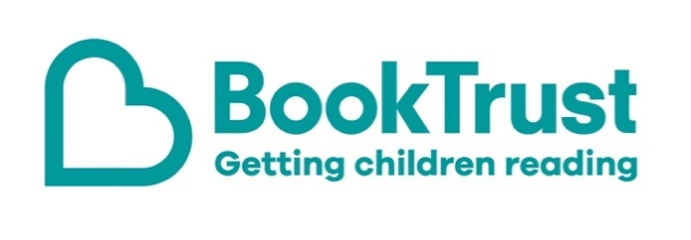

The Letterbox Club: A note to the grown-ups
Letterbox Club is a programme run by BookTrust - the UK largest children’s reading charity.
Virtual Schools and schools purchase the Letterbox Club parcels for children they feel would benefit the most and can either post or give the parcels directly to the children.
The Letterbox Club provides six parcels of books, games and stationery, for them to enjoy and keep. When each parcel arrives, you can also get involved, by reading and playing the games together.
For more information on Letterbox Club, visit: www.booktrust.org.uk/letterbox-club-families

Here's some tips to enjoy this parcel:
- King Coo: The Curse of the Mummy’s Gold has accessible chapters accompanied by illustrations. You can find out about more books like this by visiting the BookTrust website at www.booktrust.org.uk/books and searching by age range and topic.
- Cool Mind Melters is perfect for the school holidays or rainy weekends. Children can use the pencil and pens in the parcel to complete the activities by themselves or with someone else.
- Keep updated on social media. You can follow @Booktrust on Twitter to find out more about the best new books, and how you can continue encouraging reading for pleasure at home.

We hope you enjoy this parcel.
Best wishes,
The Letterbox Club Team at BookTrust

