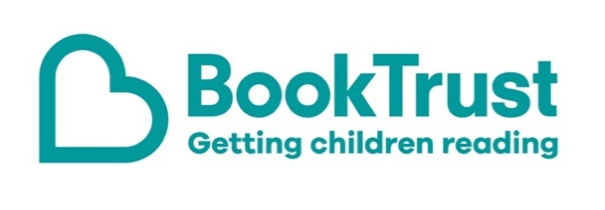

The Letterbox Club: A note to the grown-ups
Letterbox Club is a programme run by BookTrust - the UK largest children’s reading charity.
Virtual Schools and schools purchase the Letterbox Club parcels for children they feel would benefit the most and can either post or give the parcels directly to the children.
The Letterbox Club provides six parcels of books, games and stationery, for them to enjoy and keep. When each parcel arrives, you can also get involved, by reading and playing the games together.
For more information on Letterbox Club, visit: www.booktrust.org.uk/letterbox-club-families

Here's some tips to enjoy this parcel:
- The Nothing to See Here Hotel is the first book in the series, so if children enjoy this book you could visit your local library to find the next one. Plus, there is a letter from the author and illustrator included in the parcel.
- The Funniest Animal Joke Book Ever is a great book for sharing together when you only have a few minutes in the day. Tell each other your favourite jokes and try making up your own.
- Wild Facts About Nature is full of jokes, facts and activities. Together, you could talk about some of the activities and complete them together.
- Children can use the Space Pandas activity sheet to add their own ideas to the comic, and then create their own on the back. You may want to display their comic at home, to boost their confidence.

We hope you enjoy this parcel.
Best wishes,
The Letterbox Club Team at BookTrust

