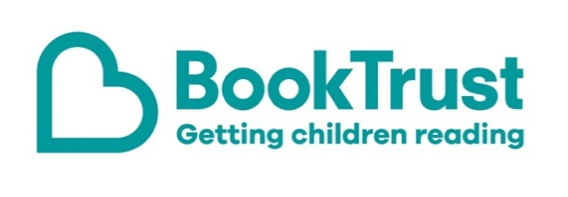

The Letterbox Club: A note to the grown-ups
Letterbox Club is a programme run by BookTrust - the UK largest children’s reading charity.
Virtual Schools and schools purchase the Letterbox Club parcels for children they feel would benefit the most and can either post or give the parcels directly to the children.
The Letterbox Club provides six parcels of books, games and stationery, for them to enjoy and keep. When each parcel arrives, you can also get involved, by reading and playing the games together.
For more information on Letterbox Club, visit: www.booktrust.org.uk/letterbox-club-families

Here's some tips to enjoy this parcel:
- DK Find Out! Bugs is a great book to dip in and out of. You could encourage children to create a poster with their favourite space facts, or a fact-file in the exercise book in this month’s parcel.
- If children enjoy The Accidental Rock Star you could encourage them to write to the author, Tom McLaughlin, to tell him what they liked about the book and to ask any questions they have.

We hope you enjoy being part of the Letterbox Club!
Best wishes,
The Letterbox Club Team at BookTrust
Did you know? Young people who read for pleasure make significantly more progress in vocabulary, spelling and maths than young people who read very little (Sullivan and Brown, 2013).

