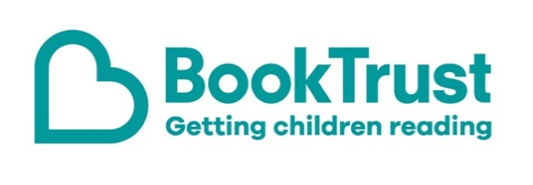
The Letterbox Club: A note to the grown-ups

Letterbox Club is a programme run by BookTrust - the UK largest children’s reading charity.

Virtual Schools and schools purchase the Letterbox Club parcels for children they feel would benefit the most and can either post or give the parcels directly to the children.

The Letterbox Club provides six parcels of books, games and stationery, for them to enjoy and keep. When each parcel arrives, you can also get involved, by reading and playing the games together.

For more information on Letterbox Club, visit: www.booktrust.org.uk/letterbox-club-families

Here's some tips to enjoy this parcel:

- Dread Cat is simple chapter book for which is perfect for children who are starting to read independently. Encourage children to look at the pictures to help them understand the story. You may want to help them look up unfamiliar words in a dictionary.
- Little First Stickers: Aquarium has over 200 reusable stickers for children to enjoy. If they like this topic, you may want to help them find out more about sea creatures or help them draw their own sea creature scene.
- When reading Dragon Post, children may need help reading the different letters in the book.

We hope you all enjoy this month’s parcel.

Best wishes,
The Letterbox Club Team at BookTrust

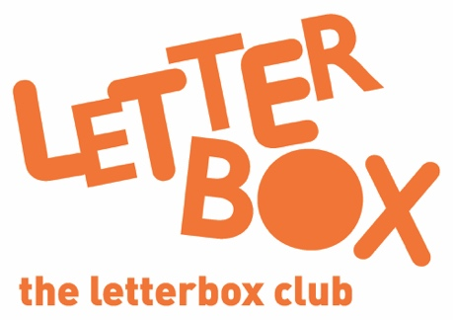
Did you know? Reading to a child daily means that they are likely to achieve better in their first year of primary school across all areas of learning and development (Hansen et al., 2010).

Did you know? Reading to a child daily means that they are likely to achieve better in their first year of primary school across all areas of learning and development (Hansen et al., 2010).

