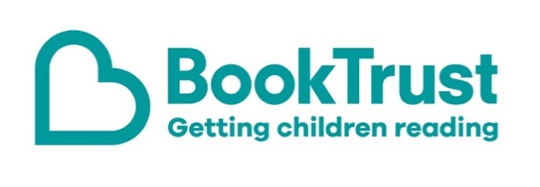
The Letterbox Club: A note to the grown-ups

Letterbox Club is a programme run by BookTrust - the UK largest children’s reading charity.

Virtual Schools and schools purchase the Letterbox Club parcels for children they feel would benefit the most and can either post or give the parcels directly to the children.

The Letterbox Club provides six parcels of books, games and stationery, for them to enjoy and keep. When each parcel arrives, you can also get involved, by reading and playing the games together.

For more information on Letterbox Club, visit: www.booktrust.org.uk/letterbox-club-families

Here's some tips to enjoy this parcel:

- Singing or saying rhymes with your child is a good way of supporting their language development. In the Swamp by the Light of the Moon is a rhyming story with repetition – when reading it, encourage children to join in with the repeated sentence.
- Joke-o-rama is a great book to share when you’ve only got a few minutes or when you’re out together - you don’t need to be sitting down. Tell each other your favourite jokes and, if children are confident enough, try making up your own.

We hope you all enjoy this month’s parcel.

Best wishes,
The Letterbox Club Team at BookTrust

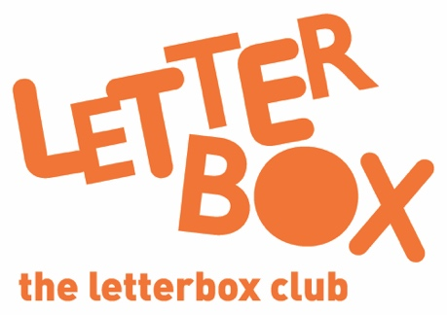
Did you know? Reading to a child daily means that they are likely to achieve better in their first year of primary school across all areas of learning and development (Hansen et al., 2010).

Did you know? Reading to a child daily means that they are likely to achieve better in their first year of primary school across all areas of learning and development (Hansen et al., 2010).

