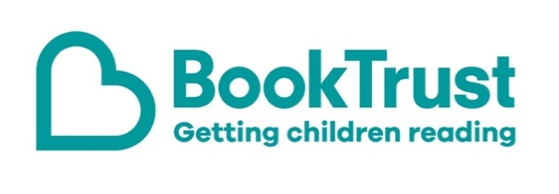
The Letterbox Club: A note to the grown-ups

Letterbox Club is a programme run by BookTrust - the UK largest children’s reading charity.

Virtual Schools and schools purchase the Letterbox Club parcels for children they feel would benefit the most and can either post or give the parcels directly to the children.

The Letterbox Club provides six parcels of books, games and stationery, for them to enjoy and keep. When each parcel arrives, you can also get involved, by reading and playing the games together.

For more information on Letterbox Club, visit: www.booktrust.org.uk/letterbox-club-families

Here's some tips to enjoy this parcel:

- We hope you both enjoy My Very First Space Book and Seek and Find: Space You can find more books about this topic and others by visiting the BookTrust website at www.booktrust.org.uk/books
- Reading The Koala Who Could might be a good opportunity talk to children about change and having the confidence to try new things. You may want to encourage them to talk about how Kevin the koala might be feeling and why, and what they think he should do next.
- Keep updated on social media. You can follow @Booktrust on Twitter to find out more about the best new books, and how you can continue to encourage reading at home.

We hope you all enjoy this month’s parcel.

Best wishes,
The Letterbox Club Team at BookTrust

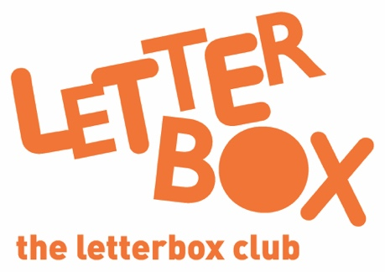
Did you know? Reading to a child daily means that they are likely to achieve better in their first year of primary school across all areas of learning and development (Hansen et al., 2010).

Did you know? Reading to a child daily means that they are likely to achieve better in their first year of primary school across all areas of learning and development (Hansen et al., 2010).

