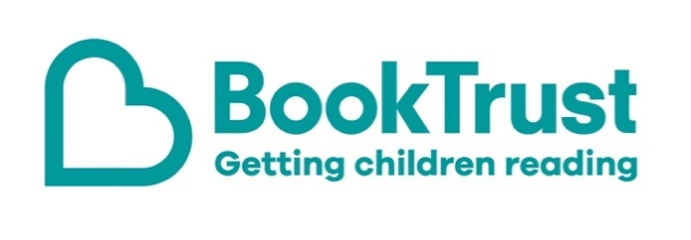
The Letterbox Club: A note to the grown-ups

Letterbox Club is a programme run by BookTrust - the UK largest children’s reading charity.

Virtual Schools and schools purchase the Letterbox Club parcels for children they feel would benefit the most and can either post or give the parcels directly to the children.

The Letterbox Club provides six parcels of books, games and stationery, for them to enjoy and keep. When each parcel arrives, you can also get involved, by reading and playing the games together.

For more information on Letterbox Club, visit: www.booktrust.org.uk/letterbox-club-families

Here's some tips to enjoy this parcel:

- Sharing books with children can be about helping them to discover that books are exciting and fun. Don’t worry if they’re not able to read or understand every word.
- When reading You Can’t Take an elephant on a Bus, talk to children about the different things you can see on each page. Pointing to them when you talk about them will help them understand unfamiliar words. Plus there are two letters from the author and illustrator included in the parcel.
- Magic Water Colouring: Roars and Claws Animals doesn’t require any paint – simply brush the pictures with water to reveal the colours. Children can enjoy painting them again and again. They may want to trace some of the pictures or even draw their own in the pages at the back, using the colouring pencils in this parcel.

We hope all enjoy this month’s parcel.

Best wishes,
The Letterbox Club Team at BookTrust
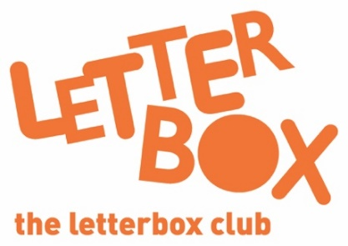
Did you know? Reading to a child daily means that they are likely to achieve better in their first year of primary school across all areas of learning and development (Hansen et al., 2010).

Did you know? Reading to a child daily means that they are likely to achieve better in their first year of primary school across all areas of learning and development (Hansen et al., 2010).

