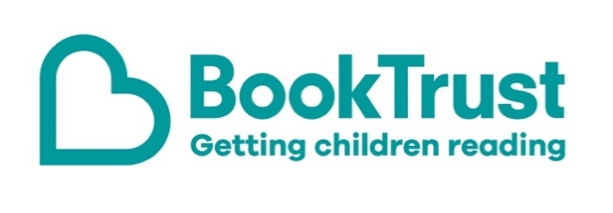
The Letterbox Club: A note to the grown-ups

Letterbox Club is a programme run by BookTrust - the UK largest children’s reading charity.

Virtual Schools and schools purchase the Letterbox Club parcels for children they feel would benefit the most and can either post or give the parcels directly to the children.

The Letterbox Club provides six parcels of books, games and stationery, for them to enjoy and keep. When each parcel arrives, you can also get involved, by reading and playing the games together.

For more information on Letterbox Club, visit: www.booktrust.org.uk/letterbox-club-families

Here's some tips to enjoy this parcel:

- When reading with children, encourage them to hold the book and turn the pages themselves.
- Peek and Seek has lots of facts about nature and is a great book for practising counting. Join in and help children count the different animals on each page. If children enjoy this book, you could find more books about the different animals and habitats at your local library.
- Open Very Carefully is an interactive story that you can enjoy together. Help children to follow the instructions in the story as you read and talk about what the crocodile might do next.

We hope you all enjoy this month’s parcel.

Best wishes,
The Letterbox Club Team at BookTrust

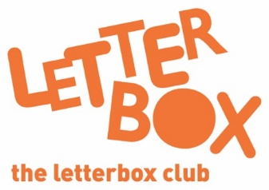
Did you know? Reading for pleasure can increase empathy, improve relationships with others, reduce the symptoms of depression and improve wellbeing throughout life (The Reading Agency, 2015).

Did you know? Reading to a child daily means that they are likely to achieve better in their first year of primary school across all areas of learning and development (Hansen et al., 2010).

Did you know? Reading to a child daily means that they are likely to achieve better in their first year of primary school across all areas of learning and development (Hansen et al., 2010).

