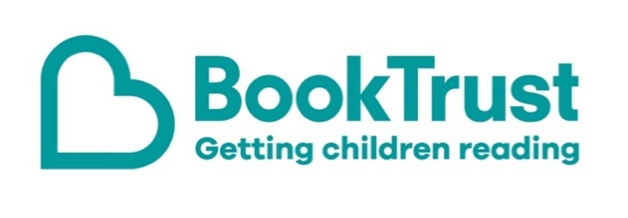
The Letterbox Club: A note to the grown-ups

Letterbox Club is a programme run by BookTrust - the UK largest children’s reading charity.

Virtual Schools and schools purchase the Letterbox Club parcels for children they feel would benefit the most and can either post or give the parcels directly to the children.

The Letterbox Club provides six parcels of books, games and stationery, for them to enjoy and keep. When each parcel arrives, you can also get involved, by reading and playing the games together.

For more information on Letterbox Club, visit: www.booktrust.org.uk/letterbox-club-families

Here's some tips to enjoy this parcel:

- Encourage children to choose a book to read with you – this will show them that their opinion matters, and they will be more likely to enjoy a book they have chosen themselves. You may need to narrow down the options to three books, to help them choose.
- Lift the Flap: First Questions and Answers: What Makes it Rain? is a great introduction to learning about the weather. It’s a great book to dip in and out of and to take with you when you’re out and about.
- When reading Max the Brave, look at the pictures together and talk about who you think Max will talk to next.

We hope you all enjoy this month’s parcel.

Best wishes,
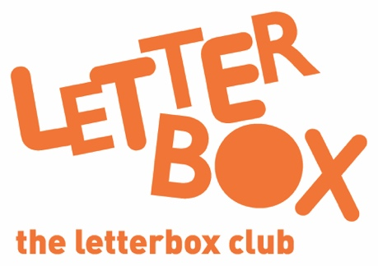
The Letterbox Club Team at BookTrust

