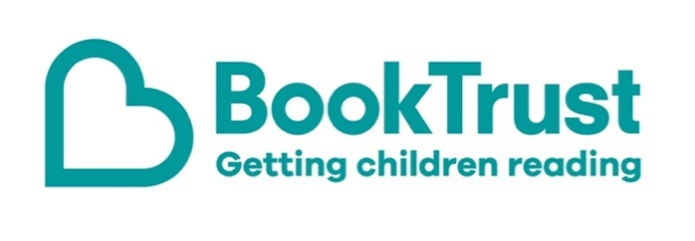

The Letterbox Club: A note to parents and carers
Letterbox Club is a programme run by BookTrust - the UK largest children’s reading charity.
Virtual Schools and schools purchase the Letterbox Club parcels for children they feel would benefit the most and can either post or give the parcels directly to the children.
The Letterbox Club provides six parcels of books, games and stationery, for them to enjoy and keep. When each parcel arrives, you can also get involved, by reading and playing the games together.
For more information on Letterbox Club, visit: www.booktrust.org.uk/letterbox-club-families

Here's some tips to enjoy this parcel:
- We hope your child enjoys The Apprentice Witch. You can find more books like this if you visit the BookTrust website and search by age range and topic: www.booktrust.org.uk/books
- Heroes is a beautifully illustrated collection of true stories about extraordinary animals who have saved lives. There’s also a letter from the author – you could encourage your child to write back with any questions they have about the book.
- The Letterbox Club Members’ Area which contains author content, activities and videos. Children don’t need to log in – just type in this link: www.booktrust.org.uk/letterbox-club-members-2

We hope you all enjoy this parcel.
Best wishes,
The Letterbox Club Team at BookTrust

