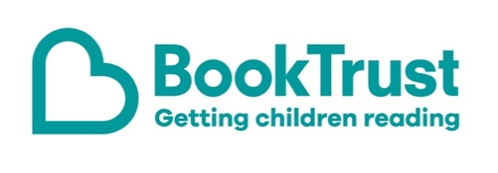

The Letterbox Club: A note to parents and carers
Letterbox Club is a programme run by BookTrust - the UK largest children’s reading charity.
Virtual Schools and schools purchase the Letterbox Club parcels for children they feel would benefit the most and can either post or give the parcels directly to the children.
The Letterbox Club provides six parcels of books, games and stationery, for them to enjoy and keep. When each parcel arrives, you can also get involved, by reading and playing the games together.
For more information on Letterbox Club, visit: www.booktrust.org.uk/letterbox-club-families

Here's some tips to enjoy this parcel:
- Boy Meets Ghoul is a laugh-out-loud story about relationships and friendships. You could encourage children to use the notepad in their parcel to write down any unfamiliar words and help them find out the meanings in a dictionary.
- Keep updated on social media. You can follow @Booktrust on Twitter to find out more about the best new books, and how you can continue encouraging reading for pleasure at home.

We hope you all enjoy this parcel.
Best wishes,
The Letterbox Club Team at BookTrust
Did you know? Reading increases a person’s understanding of their own identity, improves empathy and helps them understand the world views of others (The Reading Agency, 2015).

