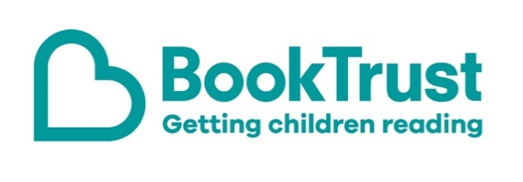

The Letterbox Club: A note to parents and carers
Letterbox Club is a programme run by BookTrust - the UK largest children’s reading charity.
Virtual Schools and schools purchase the Letterbox Club parcels for children they feel would benefit the most and can either post or give the parcels directly to the children.
The Letterbox Club provides six parcels of books, games and stationery, for them to enjoy and keep. When each parcel arrives, you can also get involved, by reading and playing the games together.
For more information on Letterbox Club, visit: www.booktrust.org.uk/letterbox-club-families

Here's some tips to enjoy this parcel:
- Why Can’t I Feel the Earth Spinning? is a good book to dip into – children don’t have to read it all at once. When you’re out and about, you could encourage children to ask questions about the things they see and help them find out the answers.
- Girl 38: Finding a Friend is a story about friendship and doing what’s right, even if it’s difficult for you. In the parcel there is also a letter from author Ewa Jozefkowicz.

We hope you all enjoy this parcel.
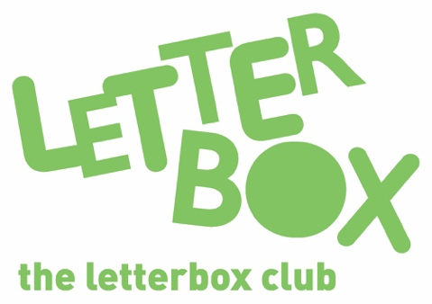
Best wishes,
The Letterbox Club Team at BookTrust

