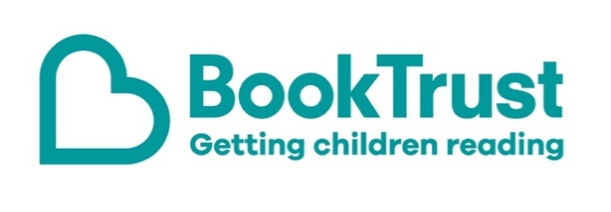

The Letterbox Club: A note to parents and carers
Letterbox Club is a programme run by BookTrust - the UK largest children’s reading charity.
Virtual Schools and schools purchase the Letterbox Club parcels for children they feel would benefit the most and can either post or give the parcels directly to the children.
The Letterbox Club provides six parcels of books, games and stationery, for them to enjoy and keep. When each parcel arrives, you can also get involved, by reading and playing the games together.
For more information on Letterbox Club, visit: www.booktrust.org.uk/letterbox-club-families

Here's some tips to enjoy this parcel:
- Money for Beginners is a useful introduction to understanding and managing money – you could share this book with children to help prepare them for adult life. You might want to help them budget their own pocket money or help them practise budgeting when you go food shopping.
- Listen Up: Rule the Airwaves, Rule the School is about two school radio hosts learning to work together and overcome their differences. You could encourage children design their own cover for the book, or even write the first chapter of a sequel.

We hope you all enjoy this parcel.
Best wishes,
The Letterbox Club Team at BookTrust
Did you know? Young people who read for pleasure make significantly more progress in vocabulary, spelling and maths than young people who read very little (Sullivan and Brown, 2013).

