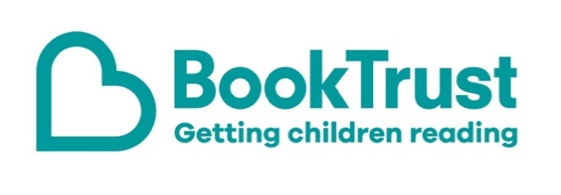

The Letterbox Club: A note to parents and carers
Letterbox Club is a programme run by BookTrust - the UK largest children’s reading charity.
Virtual Schools and schools purchase the Letterbox Club parcels for children they feel would benefit the most and can either post or give the parcels directly to the children.
The Letterbox Club provides six parcels of books, games and stationery, for them to enjoy and keep. When each parcel arrives, you can also get involved, by reading and playing the games together.
For more information on Letterbox Club, visit: www.booktrust.org.uk/letterbox-club-families

Here's some tips to enjoy this parcel:
- Paperscapes contains a range of facts alongside illustrations and press-out sections which make this book extra-special. You could encourage children to create a fact file or poster with their favourite facts from the book.
- Stop Those Monsters is about a boy on a quest to escape from the land of monsters, along with three of the monsters themselves. If your child enjoys this book you could encourage them to write an alternative ending.

We hope you all enjoy this parcel.
Best wishes,
The Letterbox Club Team at BookTrust
Did you know? Reading for pleasure can increase empathy, improve relationships with others, reduce the symptoms of depression and improve wellbeing throughout life. (The Reading Agency, 2015).

