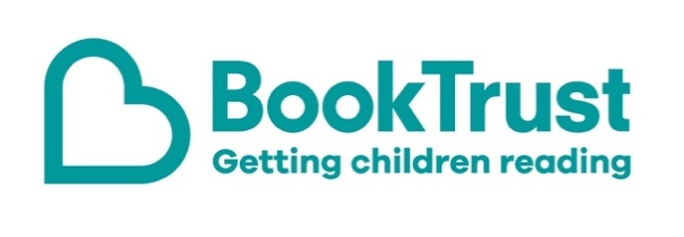

The Letterbox Club: A note to the grown-ups

Letterbox Club is a programme run by BookTrust - the UK largest children’s reading charity.

Virtual Schools and schools purchase the Letterbox Club parcels for children they feel would benefit the most and can either post or give the parcels directly to the children.

The Letterbox Club provides six parcels of books, games and stationery, for them to enjoy and keep. When each parcel arrives, you can also get involved, by reading and playing the games together.

For more information on Letterbox Club, visit: www.booktrust.org.uk/letterbox-club-families

Here's some tips to enjoy this parcel:

- The Usborne Book of Night Time is an illustrated non-fiction book about the night sky, nocturnal animals and night-time in the countryside and cities. There’s lots to look at and talk about if you’re sharing this book with children.
- Joke-a-thon is a fun book to share together when you’ve only got a few minutes. Tell each other your favourite jokes and use the Crack a Joke activity in the parcel to help children make up their own.
- We have included a special card which has login details to the Letterbox Club members’ website containing author content, activities and videos. Children don’t need to log in – just help them type in the link on their membership card.

Best wishes,
The Letterbox Club Team at BookTrust

