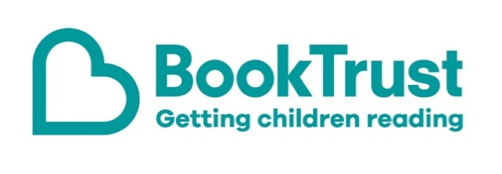

The Letterbox Club: A note to the grown-ups

Letterbox Club is a programme run by BookTrust - the UK largest children’s reading charity.

Virtual Schools and schools purchase the Letterbox Club parcels for children they feel would benefit the most and can either post or give the parcels directly to the children.

The Letterbox Club provides six parcels of books, games and stationery, for them to enjoy and keep. When each parcel arrives, you can also get involved, by reading and playing the games together.

For more information on Letterbox Club, visit: www.booktrust.org.uk/letterbox-club-families

Here's some tips to enjoy this parcel:

- Wigglesbottom Primary: The Magic Hamster is a hilarious collection of stories about primary school mayhem. Plus, children also have a letter from the illustrator, Becka Moor. If children enjoy this book, you may be able to find more books by the same author in your local library.
- Engineer in Training is a fun way for children to learn about how maths and science are used to solve problems. When you’re out, you could make links between the book and the everyday things you see, or you could talk about the activities in the book and try to solve them together.
- Keep updated on social media. You can follow @Booktrust on Twitter to find out more about the best new books and how you can continue to encourage reading at home.

We hope you all enjoy this parcel.
Best wishes,
The Letterbox Club Team at BookTrust
