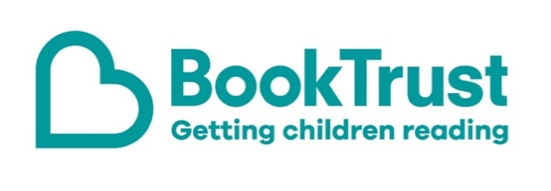

The Letterbox Club: A note to the grown-ups

Letterbox Club is a programme run by BookTrust - the UK largest children’s reading charity.

Virtual Schools and schools purchase the Letterbox Club parcels for children they feel would benefit the most and can either post or give the parcels directly to the children.

The Letterbox Club provides six parcels of books, games and stationery, for them to enjoy and keep. When each parcel arrives, you can also get involved, by reading and playing the games together.

For more information on Letterbox Club, visit: www.booktrust.org.uk/letterbox-club-families

Here's some tips to enjoy this parcel:

- We hope children will enjoy the Top Trumps: Predators cards - you can play together or help them use the Predators activity sheet also included in this month’s parcel.
- Animals Up Close includes stunning photography and accessible facts for children to enjoy. You could encourage children to create their own Top Trumps card about one of the animals in the book – they could use the felt pens in the parcel for this.
- When reading Zanzibar, encourage children write down unfamiliar words and help them look up their meanings in the dictionary. Children also have a letter from the author, Catharina Valckx, in their parcel.

We hope you all enjoy this parcel.
Best wishes,
The Letterbox Club Team at BookTrust
