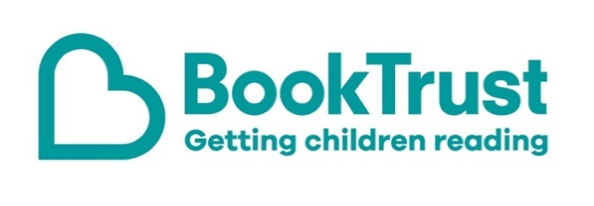

The Letterbox Club: A note to the grown-ups

Letterbox Club is a programme run by BookTrust - the UK largest children’s reading charity.

Virtual Schools and schools purchase the Letterbox Club parcels for children they feel would benefit the most and can either post or give the parcels directly to the children.

The Letterbox Club provides six parcels of books, games and stationery, for them to enjoy and keep. When each parcel arrives, you can also get involved, by reading and playing the games together.

For more information on Letterbox Club, visit: www.booktrust.org.uk/letterbox-club-families

Here's some tips to enjoy this parcel:

- Shifty McGifty and Slippery Sam: The Aliens are Coming! has three short adventures accompanied by illustrations. You can find out about more books in the series by visiting the BookTrust website at www.booktrust.org.uk/books
- Children can use the pencil included in the parcel to complete the puzzles, mazes and quizzes in The Backpack Activity Book. This book is perfect for taking away on holiday or for long journeys. You might want to complete some of the activities together.

We hope you all enjoy this parcel.
Best wishes,
The Letterbox Club Team at BookTrust
Did you know? Children who read for pleasure make significantly more progress in vocabulary, spelling and maths than children who read very little (Sullivan and Brown, 2013).

