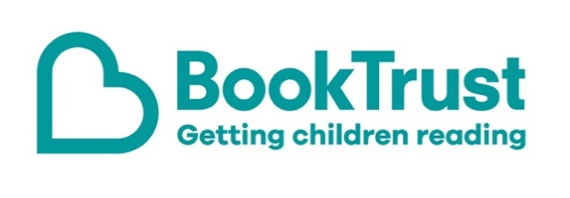

The Letterbox Club: A note to the grown-ups

Letterbox Club is a programme run by BookTrust - the UK largest children’s reading charity.

Virtual Schools and schools purchase the Letterbox Club parcels for children they feel would benefit the most and can either post or give the parcels directly to the children.

The Letterbox Club provides six parcels of books, games and stationery, for them to enjoy and keep. When each parcel arrives, you can also get involved, by reading and playing the games together.

For more information on Letterbox Club, visit: www.booktrust.org.uk/letterbox-club-families

Here's some tips to enjoy this parcel:

- The Big Sticker book of the Blue is beautifully illustrated and packed with varied facts and activities- children can use the colouring pencils in the parcel to complete these. You could even quiz each other about some of the facts in the book.
- Famous Five: The Birthday Adventure has colourful illustrations and short chapters, making it perfect for sharing together or reading independently. If children enjoy this story, you may be able to find others in the series at your local library.

We hope you all enjoy this parcel.
Best wishes,
The Letterbox Club Team at BookTrust
Did you know? Reading for pleasure can increase empathy, improve relationships with others, reduce the symptoms of depression and improve wellbeing throughout life (The Reading Agency, 2015).

