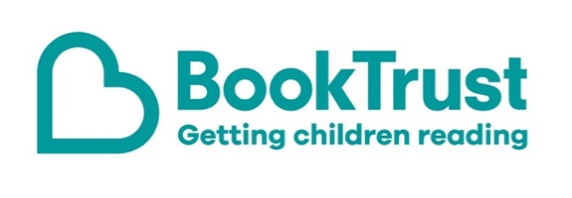

The Letterbox Club: A note to the grown-ups

Letterbox Club is a programme run by BookTrust - the UK largest children’s reading charity.

Virtual Schools and schools purchase the Letterbox Club parcels for children they feel would benefit the most and can either post or give the parcels directly to the children.

The Letterbox Club provides six parcels of books, games and stationery, for them to enjoy and keep. When each parcel arrives, you can also get involved, by reading and playing the games together.

For more information on Letterbox Club, visit: www.booktrust.org.uk/letterbox-club-families

Here's some tips to enjoy this parcel:

- A Planet Full of Plastic is great for engaging children with a current issue in today’s world. Together, you could help them find out about more topics like this by reading news stories in the papers or online with them.
- Ancient Egyptians is a fun lift-the-flap book that can help to bring history to life and build on what children might already have learnt at school. You could help them build a ‘fact file’ of their favourite facts from the book.
- Space Race is a short chapter book by former Children’s Laureate, Malorie Blackman. You can find out more about the current Children’s Laureate, Cressida Cowell, on our website: https://www.booktrust.org.uk/what-we-do/childrens-laureate/
- Children may want to write their name on the illustrated labels in the parcel and stick them in their books.

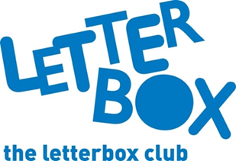
We hope you and your child enjoy being part of the Letterbox Club.
Best wishes,
The Letterbox Club Team at BookTrust
