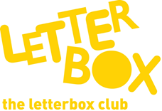

Top Letterbox Tips - Parcel 6

The Letterbox Club provides six, monthly parcels of books, games and stationery for you and your child to enjoy together. It’s run by a reading charity called BookTrust. For more information please visit www.booktrust.org.uk/letterbox-club-families
Here are some ideas for supporting your child with this month’s parcel:

- Your child might have a favourite book that they want to read again and again, rather than trying something new. That’s okay – having a favourite story can help them develop a love of reading.

- You could help your child create an extra ‘collector card’, poster or fact file using their favourite facts from the non-fiction book in this month’s parcel.
- Letterbox Club Members’ Area - We have included a special card which has login details to the Letterbox Club members’ website containing author content, activities and videos. They don’t need to log in – just help them type in the link on their membership card.

- The Boris Monster Profile is a great way of getting your child to think about descriptive words and practise their writing. If they enjoy Boris, why not draw your own monsters together and think of fun names for them?

- Keep updated on social media. You can follow @Booktrust on Twitter to find out more about the best new books, and how you can continue to encourage reading for pleasure at home.

We hope you have both enjoyed receiving Letterbox Club parcels!
Best wishes,
The Letterbox Club Team

