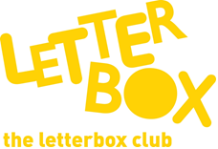

Top Letterbox Tips - Parcel 5

The Letterbox Club provides six, monthly parcels of books, games and stationery for you and your child to enjoy together. It’s run by a reading charity called BookTrust. For more information please visit www.booktrust.org.uk/letterbox-club-families
Here are some ideas for supporting your child with this month’s parcel:

- Encourage your child to take a book with them to read or look at during car, bus or train journeys, to help them develop a reading habit.

- The Funniest Joke Book Ever is a good book to share for five minutes or when you’re out together - you don’t need to be sitting down. Tell each other your favourite jokes and use the Crack a Joke activity sheet to help your child make up their own.

- We hope you both enjoy reading Mortimer Keene: Dino Danger. If you’re reading it to your child, try to use your tone of voice to show them the rhythm of the story. You can find more books by the same author and others by visiting the BookTrust website at www.booktrust.org.uk/books

- After you have played Pairs using the cards in the parcel, you could make your own pairs cards together, using the pencil in the parcel to draw the pictures.

We hope you both enjoy this month’s parcel.

The Letterbox Club Team

