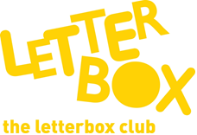

Top Letterbox Tips - Parcel 4

The Letterbox Club provides six, monthly parcels of books, games and stationery for you and your child to enjoy together. It’s run by a reading charity called BookTrust. For more information please visit www.booktrust.org.uk/letterbox-club-families
Here are some ideas for supporting your child with this month’s parcel:

- Sharing books with your child helps them to discover that books are exciting and fun. Don’t worry if they’re not able to read or understand every word.
- Sharks, Seahorses and other British Sea Creatures contains lots of stickers and facts. Why not ask your child about their favourite fact, or go to the library to find more books about the ocean? Together, you and your child can use the checklist at the end of the book to spot the different sea creatures.

- If they want to, your child can stick the Nick Sharratt name labels into their Letterbox Club books.

- You could use the dominoes in the parcel to play snap – take it in turns to turn over the dominoes and shout ‘snap’ if a number is the same.

Best wishes,

The Letterbox Club Team

Did you know? Children who read for pleasure make significantly more progress in vocabulary, spelling and maths than children who read very little (Sullivan and Brown, 2013)

