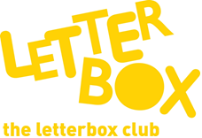

Top Letterbox Tips - Parcel 3

The Letterbox Club provides six, monthly parcels of books, games and stationery for you and your child to enjoy together. It’s run by a reading charity called BookTrust. For more information please visit www.booktrust.org.uk/letterbox-club-families
Here are some ideas for supporting your child with this month’s parcel:
- Encourage your child to choose a book to read with you – this will show them that their opinion matters, and they will be more likely to enjoy a book they have chosen themselves. You may need to narrow the choice down to three books to help them decide.
- When reading The Truth About My Unbelievable School, you could help your child understand the meaning of new words by looking at the pictures or looking them up in a dictionary. Together, you could use the notepad in the parcel to write down new words.

- National Geographic Sticker Doodle Book is a fun book that your child can use over the summer holidays. It’s a good one to dip in and out of, or for long car journeys.

- Magnetic Fishing – when playing magnetic fishing, you could encourage your child to use the notepad in the parcel to keep track of how many fish you each get per go. Help them add up the scores!

Best wishes,

The Letterbox Club Team

