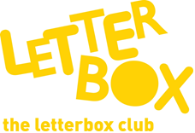

Top Letterbox Tips - Parcel 2

The Letterbox Club provides six, monthly parcels of books, games and stationery for you and your child to enjoy together. It’s run by a reading charity called BookTrust. For more information please visit www.booktrust.org.uk/letterbox-club-families
Here are some ideas for supporting your child with this month’s parcel:
- If your child enjoys Look Inside: How Things Work you could try and link some of the facts in the book with things they might see or use in everyday life. For example, after reading the book, you could point out the items in real life, and see if either of you can remember how they work.

- We hope you both enjoy reading I Can Only Draw Worms. You and your child could challenge each other to draw the best worm, or even something more creative!

- If your child enjoys the books is this month’s parcel you could check your local library to see if there are more books from the series or similar stories. They might even be holding an event that your child could attend.

- Squishy Races is a fun game to help your child practise their counting. It can be played alone, but why not have a go? You could make it more challenging by creating your own rules. For example, if you get a 2, you must go back two spaces instead of forward.

Best wishes,

The Letterbox Club Team

