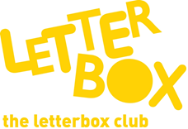

Top Letterbox Tips - Parcel 1

The Letterbox Club provides six, monthly parcels of books, games and stationery for you and your child to enjoy together. It’s run by a reading charity called BookTrust. For more information please visit www.booktrust.org.uk/letterbox-club-families
Here are some ideas for supporting your child with this month’s parcel:
- Remember, reading and discussing books with your child has many benefits and will help to develop their confidence across a range of subjects. Taking just a few minutes each day to share a story can be a good opportunity to spend time together.

- T.Rex Time Machine is a great book for sharing. Encourage your child to look at the pictures and talk with them about what they can see happening on some of the pages.

- Superhero Snap! is a fun way for you and your child to spend time together. Together, talk about the different superhero powers the characters might have, and what their superhero names might be. You could even talk about a superhero power you would like to have!

- One to Nine Bingo can be played by 2, 3 or 4 people. Your child might need some help with cutting out the bingo cards!

We hope you both have fun.

The Letterbox Club Team

Did you know? Reading for pleasure can increase empathy, improve relationships with others, reduce the symptoms of depression and improve wellbeing throughout life (The Reading Agency, 2015).

