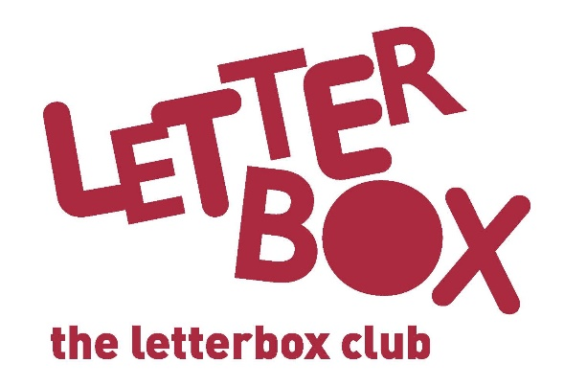

Top Letterbox Tips - Parcel 6
The Letterbox Club provides six, monthly parcels of books, games and stationery to children and young people across the UK. It’s run by a reading charity called BookTrust. For more information please visit www.booktrust.org.uk/letterbox-club-families

Here are some ideas for supporting your child with this month’s parcel:
- You could help your child design their own book cover for A Boy and a Bear in a Boat using the sketch book in the parcel. Why not display it at home to help boost their confidence?

- Your child will also receive Top Trumps: Deadliest Predators, and an accompanying activity that could be fun to do together.

- Letterbox Club Members’ Area - We have included a special card which has login details to the Letterbox Club members’ website containing author content, activities and videos. They don’t need to log in – just help them type in the link on their membership card.

- You can play the £500 game and the £600 game with your child and change the rules to make it more challenging. For example, if anyone lands on a blank space, they must give back £50. Encourage your child to practise adding and subtracting as they play.

We hope you’ve both enjoyed being part of the Letterbox Club team!
Best wishes,
The Letterbox Club Team

