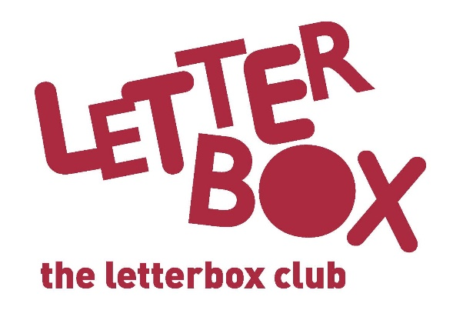

Top Letterbox Tips - Parcel 5
The Letterbox Club provides six, monthly parcels of books, games and stationery to children and young people across the UK. It’s run by a reading charity called BookTrust. For more information please visit www.booktrust.org.uk/letterbox-club-families

Here are some ideas for supporting your child with this month’s parcel:
- Remember, reading and discussing books with your child has many benefits and will help to develop their confidence across a range of subjects. Taking just a few minutes each day to share a story can be a good opportunity to spend time together.

- What’s Missing? and The Forty-Nine Game can both be played with more than one person. When playing What’s Missing? you could set yourselves a time limit to make it more challenging or use more cards to make up more complicated sums.

- The Treehouse Fun Book is full of fun games, puzzles and drawings. You and your child could talk about some of the activities and complete them together.

- Your child may want to read a book more than once because they enjoy it, and that’s okay!

Best wishes,
The Letterbox Club Team
Did you know? Reading increases a person’s understanding of their own identity, improves empathy and helps them understand the world views of others (The Reading Agency, 2015)

