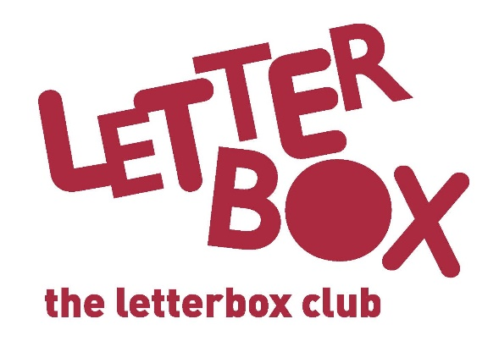

Top Letterbox Tips - Parcel 4

The Letterbox Club provides six, monthly parcels of books, games and stationery to children and young people across the UK. It’s run by a reading charity called BookTrust. For more information please visit www.booktrust.org.uk/letterbox-club-families

Here are some ideas for supporting your child with this month’s parcel:
- If your child prefers to read independently, you could both read at the same time. It can be time to relax together and it’s great for them to see you reading too!

- Encourage your child to write their own story or comic based on the characters and scenes in Stickyscapes: Superheroes.

- The Eighteens and 999 games can be played with two people. Try making them more challenging by playing them again to make other numbers!

- If your child enjoys reading The Phantom Lollipop Man you could visit your local bookshop to ask for advice about similar books, or visit the Booktrust website at www.booktrust.org.uk/bookfinder and search similar books by age range and topic.

We hope you both have fun with the items in this month’s parcel!

Best wishes,
The Letterbox Club Team

