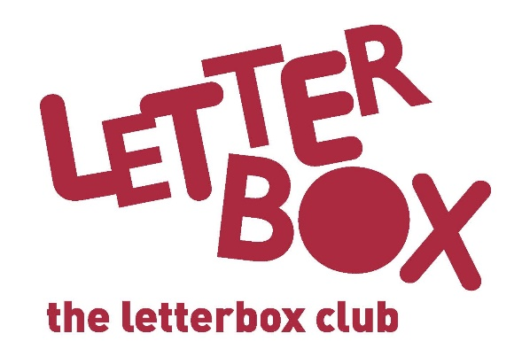

Top Letterbox Tips - Parcel 2
The Letterbox Club provides six, monthly parcels of books, games and stationery to children and young people across the UK. It’s run by a reading charity called BookTrust. For more information please visit www.booktrust.org.uk/letterbox-club-families

Here are some ideas for supporting your child with this month’s parcel:
- The Awesome Book of Space is a great book to dip in and out of. You could encourage your child to create a poster with their favourite space facts, or a fact-file in the exercise book in this month’s parcel.

- If your child enjoys reading Night Zoo Keeper, you could visit your local library to find more books in the series. You might want to encourage them to write a letter to the author to tell them what they liked about the book.

- You might want to help your child to use the Rabbits Postcard in the parcel to write to us. We’d love to hear what they think about the Letterbox Club!

- Your child can use the Space Pandas activity sheet to add their own ideas to the comic, and then create their own on the back. You could display their comic as a way of encouraging them and building their confidence.

Best wishes,
The Letterbox Club Team

